Wendy Noreña

December 13th, 2016

EA30 Final

Georgia and Climate Change

Established in 1732 as the thirteenth colony in the, “New World,” Georgia remains a state heavily influenced and informed by its colonial history and turbulent, often cruel, past (History.com). From my personal experience, there is a heavy emphasis on remembering, honoring, and understanding the past in Georgia. However, the way in which this manifests itself varies depending on your location in the state, especially in regards to the evolution of racial relations and civil rights—in urban centers, you might spend time honoring the activism of Martin Luther King Jr., while in rural communities you might proudly display and defend the confederate flag. The same attitude and divisiveness regarding Georgia’s racial history applies in a similar fashion to the issue of climate change in the public sphere—often, tensions on race and the climate are divided along the same line. Sometimes, however, the divisions aren’t as clear as they seem, especially when it comes down to the interests of specific communities and individuals.

In Atlanta—Georgia’s economic, social, and political epicenter—you will find a progressive atmosphere sometimes vastly different from that of more rural areas. For example, Advocate magazine currently ranks Atlanta as the 5th “gayest” city in America, though it has topped the list several times in the past decade. Meanwhile, this past year five Republican representatives from rural districts (the largest of which boasts a population of 30,000) along with one of two Republicans out of 14 Atlanta representatives (who later voted Nay on the Act) sponsored the Free Exercise Protection Act (HB 757 2015-2016 Regular Session). This bill would have allowed businesses and religious officiators to deny service to LGBTQ+ citizens as well as allow employers to fire workers based on their sexual and gender orientation (Los Angeles Times). Governor Nathan Deal, a Republican himself from a small, rural town of 5,000, vetoed the bill. Deal was quoted by the Atlanta Journal Constitution saying, “I hope that we can all just take a deep breath, recognize that the world is changing around us, and recognize that it is important that we protect fundamental religious beliefs… But we don’t have to discriminate against other people in order to do that.” Clearly, the political situation in Georgia is a highly complicated one, largely due to rapidly changing demographics and markedly divided population. This complex political situation consequently affects and drives action (or lack thereof) pertaining to the environment and climate in as confusing a way as it does for social issues like LGBT rights.

Georgia is a starkly separated state—it’s very much a rural vs. urban kind of situation as well as a racially segregated one. The Metro Atlanta area, which consists of 39 counties all centered around Atlanta proper, contains 62% of Georgia’s total population as well as the largest nonwhite population in the state. Dustin Cable’s, “Racial Dot Map,” which takes 2010 census data and represents everyone as a colored dot denoting their race (Figure 1) clearly demonstrates the way population and race are distributed in the state. For the most part, Georgia’s population is clustered around Atlanta and a few other urban centers. Most non-white Georgia citizens are found in Atlanta but there are some black communities distributed around the state—most certainly due to the history of enslavement in the region. The diversity of identity and opinion in Atlanta thus lends itself more readily to dedicated discourse about a potentially changing climate—the groundwork for open discussion between diverse stakeholders might more readily exist in a city (where such discussions might have already been necessary for other social issues) as opposed to less diverse towns in the state where 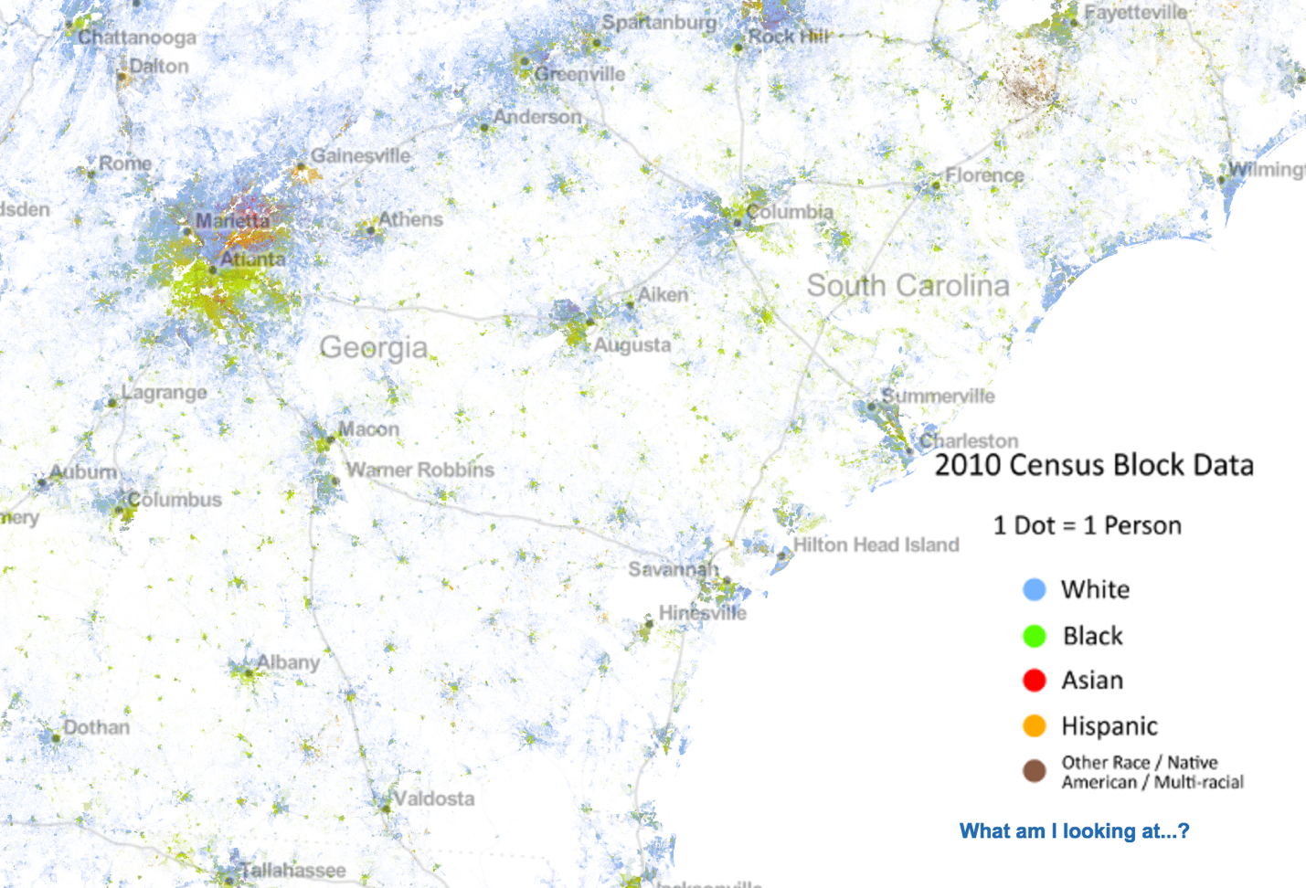differences in opinion and lifestyle might not be as common.

**Figure 1.** Screengrab of Dustin Cable’s Racial Dot Map. A faint dotted grey line denotes the Georgia’s borders. The state’s non-white population as well as most the general population are almost exclusively hosted in the Atlanta metro area.

Besides making some interesting and perhaps surprising political choices, Governor Nathan Deal is also well known for creating a massive boom in business for the state, leading Georgia to be named the top state for business for four years in a row as well as creating 575,000 private sector jobs since his employment in 2011 (Georgia.gov). Notably, most of these jobs are being created for and within metropolitan areas. Rural areas are still, for the most part, doing what they’ve always done. Throughout history, Georgia’s economy was based chiefly on agriculture driven by slavery in the 18th and 19th century (especially poignant in the image of cotton-picking as an emblem for slavery—the cotton gin was invented in Georgia). Georgia still relies heavily on agriculture for its economy, boasting the, “Pecan Capital of the World,” as well as the, “Poultry Capital of the World,” in Northern Gainesville. Peaches, cotton, beef, peanuts, dairy, vegetables, and other agricultural products are also mainstays of the agricultural economy. Farmland makes up 26% of Georgia’s landmass and agriculture makes up 18% of Georgia’s annual economy (Georgia Farm Bureau).

Georgia’s climate is largely the reason for agriculture’s success. Georgia boasts a mild, humid subtropical climate (Georgia.org). The summers are hot, often exceeding 90 degrees Fahrenheit, humid, and rainy; winters are dry, mildly cold, and only bring very rare snowfall. From North to South, the geological and physical characteristics of Georgia vary significantly, with the Appalachian Mountains in the north, marshy swamp lands trickling down to the Okefenokee Swamp, and gradual coastal slopes heading down to the Atlantic Ocean and the historic city of Savannah (Physiographic Map of Georgia). Because of this diversity in landscape, climate change will likely affect Georgia differently from region to region. We already see some examples of this now, even with just a slight change in temperature. For example, Tybee Island, a very popular island destination off the coast of Savannah, is suffering economic losses as well as structural issues from flooding due to sea level rise. In October of 2015, Tybee was cut off from the mainland when U.S. 80, a low-lying road that serves as the only non-aquatic way off the island, was inundated when a 10.47-foot high tide came in. The mayor of the island, Jason Buelterman, notes that while US 80 is flooded a few times a year, it usually occurs after a significant storm event. There was no such event during this flood, which was listed as the third-highest on record (Galloway).

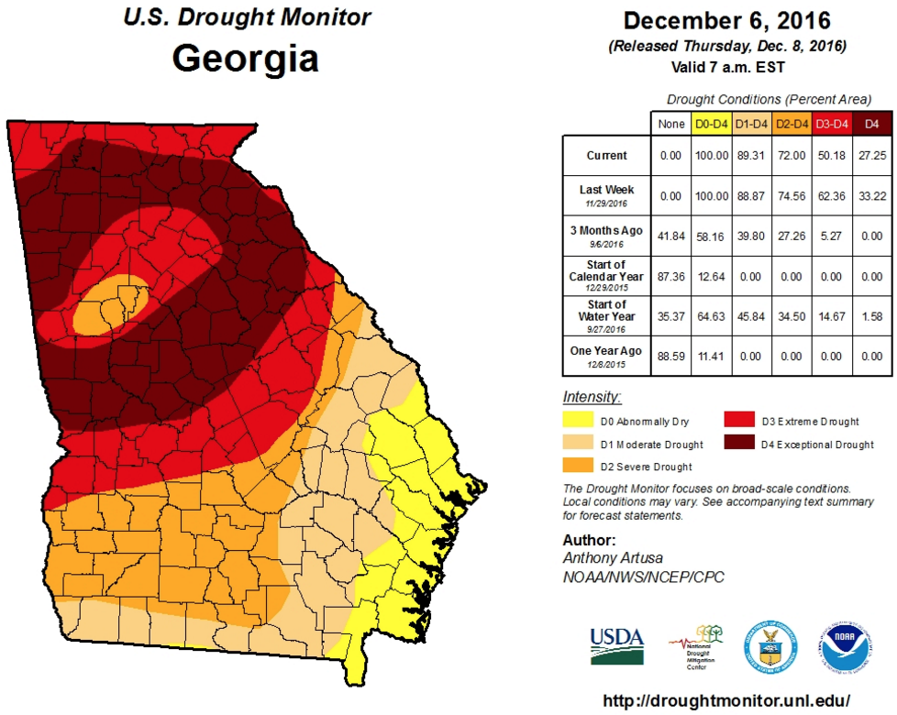Meanwhile, following severe drought conditions that have devastated the state for 6 months (Figure 2), wildfires are raging in mountain towns in the North as well as all over the state—just a month ago, the Georgia Forestry Commission responded to 170 fires over the course of four days. (Phillips, Foreman). Overall, it seems Georgia is, at the very least, experiencing an uptick in extreme weather events especially pertaining to heat and drought.

**Figure 2.** Map indicating drought levels for the state of Georgia. While the entire state is currently in drought about half of the state is currently experiencing exceptional or extreme drought.

From NOAA temperature data taken from the Atlanta Hartsfield Jackson International Airport station that runs from1930 to 2016, it’s clear temperatures are on an upward trend, even if only slightly. I graphed the average minimum and maximum temperatures for each month over the course of 86 years to try to get a sense of how the climate might be changing based on season. I processed the decades of NOAA data using R and found whether average temperature trends were significant using a linear model. Though for many of the months the data doesn’t show a significant result (yet!) I did find a few interesting and significant trends for the airport station data. The average minimum temperature for August was the most significant trend I found, with a p-value of 6.682e-05 which is contrasted with the average maximum temperature for August which displayed a generally positive trend but came in with a p-value of 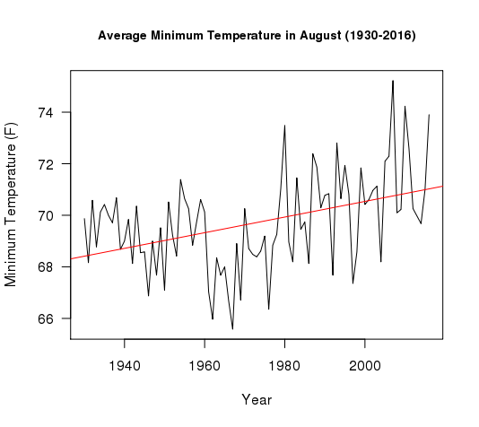just 0.2845 (Figure 3, 4). The same was true for the month of July. This data is consistent with

**Figure 3.** The average minimum temperature for August from 1930 to 2016 showcases an obvious upward trend with an impressive p-value of 6.682e-05.

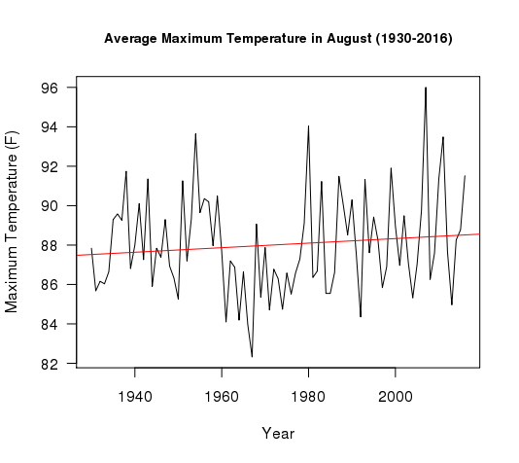**Figure 4.** The average maximum temperature for August from 1930 to 2016 indicates a slight positive trend but does not come up as significant with a p-value of 0.2845.

recent findings from the National Climate Assessment Development Advisory Committee, which found that an increasing number of summer days are above temperatures of 95 F; this type of weather condition results in a worrying increase in heat-related health conditions (heat exhaustion or heat stroke) as well as deaths.

The only month for which both the average minimum and maximum temperatures showed increase was March, with p-values of 0.001597 and 0.009, respectively (Figure 5, 6). Interestingly, the winter months had no significant upwards trends. In some cases, the trend was negative, like in the case of January, which showed an almost flat trend for average maximum temperature (p-value = 0.9758) and a visibly downward sloping line for the average minimum temperature (p-value = 0.2902) (Figure 7,8).

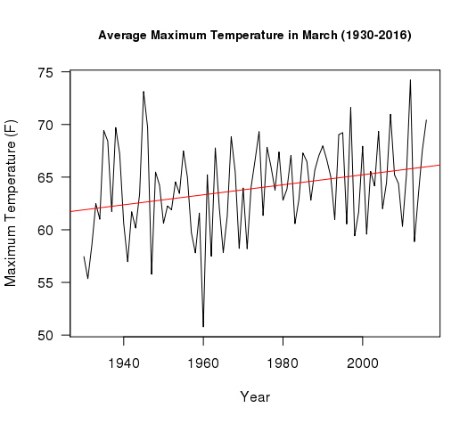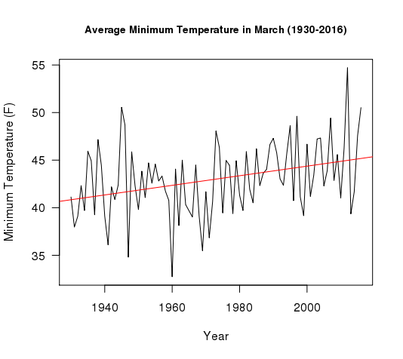

**Figure 5.** The average minimum temperature in March indicates a significant positive upward trend with p-value 0.001597.

**Figure 6.** The average maximum temperature in March indicates a significant positive upward trend with a p-value of 0.009.

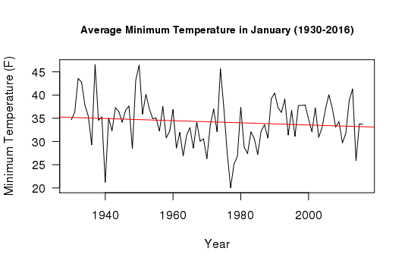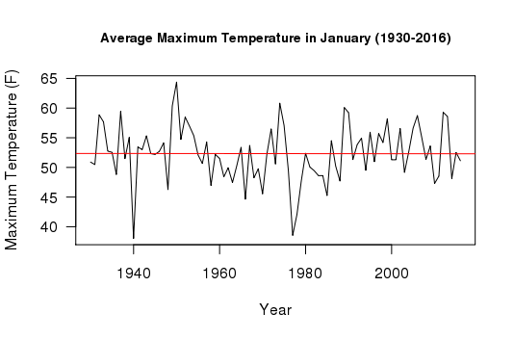

**Figure 8.** The average minimum temperatures for January are indicating a decrease. This trend is not significant, with a p-value of 0.2902.

**Figure 7.** January average maximum temperatures have seemingly not changed based on this nearly flat trend with a p-value of 0.9758.

Though I did not find a scientific source on this, my findings on winter months is consistent with both my own anecdotal experience and with anecdotal evidence from Georgia farmers, one of whom was quoted by Georgia Organics saying:

‘*We had three snowfalls this past winter. I lived in Georgia most of my whole life and I don’t ever recall having that many. The one we had in January stayed out here [on the fields] for three weeks,” says Jonathan Szecsey, of A&J Farms in Winston, Ga. “The weather runs in cycles but I have never seen it like this. I’m not saying it has anything to do with global warming, but it’s strange that all this has occurred.”*

Snowfall in Georgia seems to be increasing all over the state, which politically makes the discussions about climate change even more difficult. For one, climate change is still commonly known as global warming, a term that causes confusion because of its deviation from perceived weather patterns and the actual reality of climate change. In the scientific community, we know climate change doesn’t necessarily mean warming but means a change to a complex global system of weather patterns. Most laymen don’t know that, and, unfortunately for the entire world, many politicians don’t know or understand it either.

For some reason, a distrust of science is common and widely accepted in the political sector. As a national community, we must pinpoint and mediate the cause of this phenomenon, but, in the meantime, it is best to meet politicians and powerful officials where they are. Often, by positioning a climate situation as an economic argument, politicians typically reluctant about the concept of climate change are more likely to support mediation ideas. In truth, it may not be possible to teach an old dog new tricks—the men in power grew up in times where resources were plentiful and there was little to no word spoken about nature running out of its bounty. As we’ve discussed in class, people internalize the status quo of their upbringing and judge the rest of their lives against this baseline. We may never be able to convince older generations about the truth of a shifting environmental paradigm but we may be able to get them on board for environmental mitigation if we frame the discussion in a way that doesn’t center a sort of guilty-doomsday banter. That may sound harsh to say, but it is true that many climate arguments are made with the core idea that time is running out and humanity is to blame. If we can compromise with skeptical politicians and authority figures by advocating for environmentally-advantageous changes based on economic, religious (some people react well to calls for “preserving God’s gift to man!”), and social reasons we may be able to make more of a difference than by environmental or ecological arguments alone.

Overall, Georgia is seeing a stark increase in extreme weather events including wildfires, extreme heat waves, flooding, and extensive drought. These are all conditions that significantly threaten human life and property, especially for people who already come from underprivileged and minority backgrounds. While the city of Atlanta started working on a Climate Change Action Plan last year, the rest of the state has not yet reached that point. Unfortunately, climate change will affect the entire state even if it doesn’t do so in the exact same ways and these negative effects are likely to manifests themselves in the very near future. A public discourse between Georgia’s urban center and its large rural community as well as tangible action for mitigation and climate change planning must be put in place, and soon, because it is clear climate change effects are already present in the state and will continue to harm Georgia’s most vulnerable. Hopefully, with the incoming generation of young, educated Georgians (myself included) this work will begin before the situation truly becomes dire and dangerous for the diverse community that calls the state home.

Works Cited

“A State Divided.” 2016. Accessed December 13. <http://www.ourgeorgiahistory.com/history101/gahistory10.html>.

“Climate.” 2016. *Georgia Department of Economic Development*. Accessed December 13. <http://www.georgia.org/competitive-advantages/lifestyle/georgia-climate/>.

“Climate Action Plan.” 2016. *P2CATL*. Accessed December 14. <http://p2catl.com/climate-action/>.

“Climate Change Could Hit Atlanta Hardest, UGA Research Predicts.” 2016. Accessed December 13. <http://onlineathens.com/local-news-uga/2013-04-13/climate-change-could-hit-atlanta-hardest-uga-research-predicts>.

“Deal Elevates Drought Response Levels, Further Restricts Outdoor Water Use | Governor Nathan Deal Office of the Governor.” 2016. Accessed December 13. <http://gov.georgia.gov/press-releases/2016-11-17/deal-elevates-drought-response-levels-further-restricts-outdoor-water-use>.

Galloway, Jim. 2016. “At Sea Level, Climate Change in Georgia Is More than Theoretical | Political Insider Blog.” Accessed December 14. <http://politics.blog.ajc.com/2015/10/31/at-sea-level-climate-change-in-georgia-is-more-than-theoretical/>.

“Georgia - U.S. States.” 2016. *HISTORY.com*. Accessed December 13. <http://www.history.com/topics/us-states/georgia>.

“Georgia Farm Bureau - About Georgia Agriculture.” 2016. Accessed December 13. <http://www.gfb.org/aboutus/georgia_agriculture.html>.

“Georgia Ranked No. 1 State for Business for Fourth Consecutive Year | Governor Nathan Deal Office of the Governor.” 2016. Accessed December 13. <http://gov.georgia.gov/press-releases/2016-11-02/georgia-ranked-no-1-state-business-fourth-consecutive-year>.

“GEORGIA_NCA_2014.pdf.” 2016. Accessed December 14. <https://www.whitehouse.gov/sites/default/files/docs/state-reports/GEORGIA_NCA_2014.pdf>.

“HB 757 2015-2016 Regular Session.” 2016. Accessed December 14. <http://www.legis.ga.gov/Legislation/en-US/display/20152016/HB/757>.

*Los Angeles Times*. 2016. “Georgia Governor Vetoes Bill Favored by Foes of Same-Sex Marriage,” March 28. <http://www.latimes.com/nation/la-georgia-governor-religious-exemptions-bill-20160328-story.html>.

“National Climate Assessment and Development Advisory Committee.” 2016. *GlobalChange.gov*. Accessed December 14. <http://www.globalchange.gov/ncadac>.

“North Georgia Wildfire Expected to Prompt Evacuations.” 2016. *Myajc*. Accessed December 13. <http://www.myajc.com/news/local/north-georgia-wildfire-expected-prompt-evacuations/vM80o6NgdN4CL8ECptBRSP/>.

Phillips, Ariella. 2016. “Wildfires Continue to Torch Georgia amid Drought.” *Ajc*. Accessed December 13. <http://www.ajc.com/news/local/latest-fire-breaks-out-georgia-gwinnett-college-campus/yQ9Xuepv01zvBbohlmF2xM/>.

“Physiographic Map of Georgia.pdf.” 2016. Accessed December 13. <https://epd.georgia.gov/sites/epd.georgia.gov/files/related_files/site_page/SM-4.PDF>.

Pierce, Charles P. 2016. “Did You Notice North Carolina and Georgia Are Currently Burning Down?” *Esquire*. November 15. <http://www.esquire.com/news-politics/politics/news/a50708/southeast-wildfires-trump-climate-change/>.

“The Racial Dot Map: One Dot Per Person | Weldon Cooper Center for Public Service.” 2016. Accessed December 13. <http://www.coopercenter.org/demographics/Racial-Dot-Map>.

“The Impact of Climate Change on Georgia Food and Farms.” *Georgia Organics*. Accessed December 14. <https://georgiaorganics.org/news-center/news-articles/the-impact-of-climate-change-on-georgia-food-and-farms/>.

“What-Does-Climate-Change-Mean-for-Georgia.pdf.” 2016. Accessed December 14. <http://www.usclimatenetwork.org/resource-database/what-does-climate-change-mean-for-georgia>.